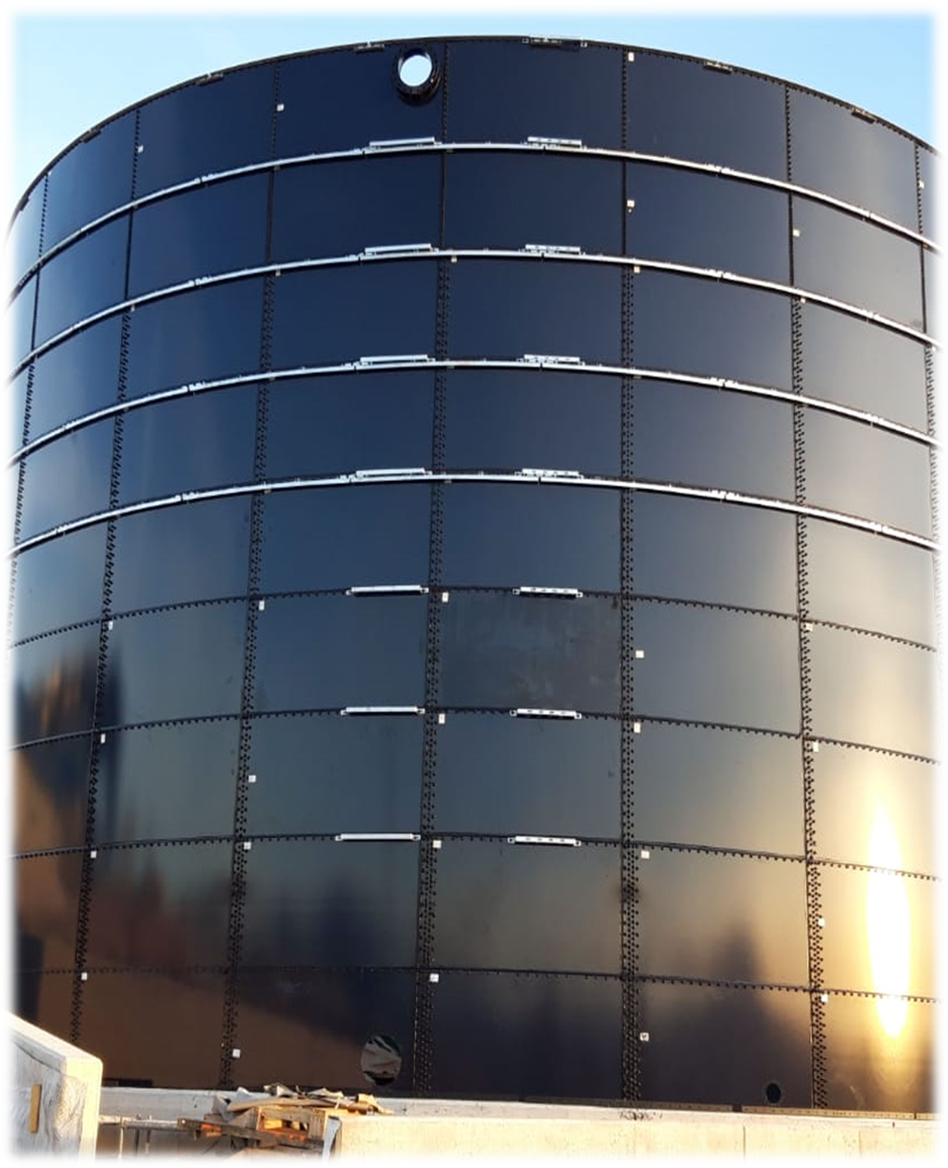

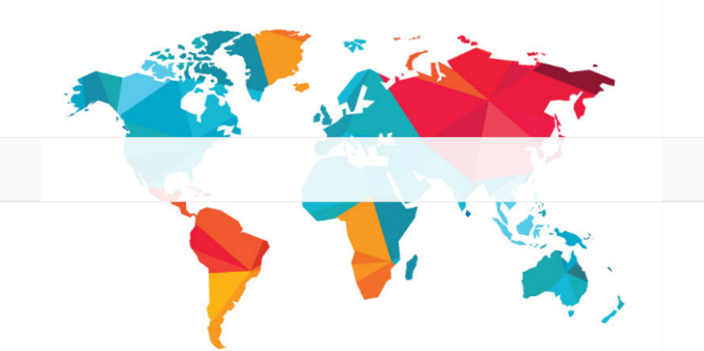
QUOTATION
<localización>
location:
quotation number:

<O-AA.NNN>

<Título>

title:
date:
06/02/2020



client:



TABLE OF CONTENTS
1. INTRODUCTION 2
2. SUPPLY 3
Tank 3
Roof 3
Accessories 3
3. PRICE LIST 4
4. COMMERCIALES TERMS 5
Exclusions 5
Payment method 6
Validity of the Offer 6
Delivery Time 6
Dominio Reserve 6
Warranty 6

INTRODUCTION

The purpose of this document is the economic proposal of:

300 m³ tank with flat cover, made of Glass Fused to Steel sheets. This offer includes optional transport <incoterm> delivered at <lugar de entrega>.

Calculation and structural design according to codes:
- EC 1990 – Basis of structural design
- EC 1991-1 – Part 1-1: General actions
- EC 1991-4 – Part 1-4: Action on structures – General actions – Wind load
- EC 1993-1-1 – Design of Steel structures – Part 1-1: General rules and rules for buildings
- EC 1993-1-5 – Design of Steel structures – Part 1-5: Plated structural elements
- EC 1993-1-6 – Design of Steel structures – Part 1-6: Strength and stability of shell structures
- EC 1993-1-8 – Design of Steel structures – Part 1-8: Design of joints
- AWWA D103-09

ARTEIN structures have a predicted minimum 30 year design life based on a comprehensive assessment of the service life of the components used in the structure, in compliance with the requirements of ISO 15686-1:2011, ISO 15686-2:2012 and ISO 15686-3:2002.

The design assumes a top liquid level no higher than the operational freeboard, contents at ambient temperature with specific gravity as detailed. No loads, cut-outs or fitments should be applied to the tank without prior consultation and advice. In circumstances where commercial factors or ongoing process requirements dictate that future access for inspection and maintenance will be impractical, the end user may wish to consider cathodic protection. The application considerations are set out in our Glass-Fused-to-Steel Specification Guide and the chemical resistance and physical properties of the glass coatings are published in Quality Standards. Copies are available upon request.

ARTEIN assumes that the structures provided as part of this quotation are to be constructed on to suitably designed and verified civil foundations. Whether the foundation is new or existing does not preclude the requirement to ensure the ground conditions and civils design are suitable for the applied loads from the new ARTEIN tank structures. Projects specific loads applied from the ARTEIN tank structure will be provided during the Sales order process. ARTEIN assume no responsibility for issues arising from insufficient or unsuitable foundation designs.
NB Environmental parameters to be confirmed by ARTEIN prior to order placement

PRICE LIST
Further to your enquiry we are pleased to provide our quotation as follows:

Item | Description | Price (€)
T1 | 1 x Chlorination Tank - Model 2805 | 38.028
T2 | 1 x Effluent Storage Tank - Model 5320 | 24.567
T3 | 2 x Aerobic Lucas Tank - Model 7620 | 123.230
I | Installation | 8.000
T | Transport | 3.800
 | Total | 59.771 €

Civil works not included in the price.
This budget does not include valves and instruments.
The price of a supervisor is 650 euros / day. Excluding travel, accommodation and maintenance.
Periodo del proyecto: 9 meses

These prices are net. They do not include taxes.

ARTEIN has no responsibility for the design and execution of civil works, as well as future settlements of land that may occur.

ARTEIN will provide only the characteristics of the foundation detail and slab required to be designed by a local civil engineer or designer.

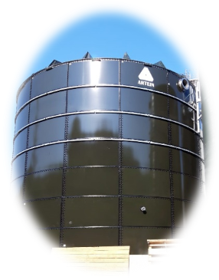
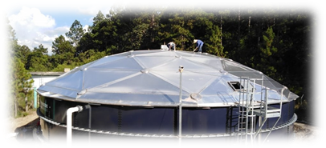

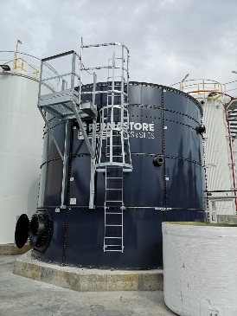
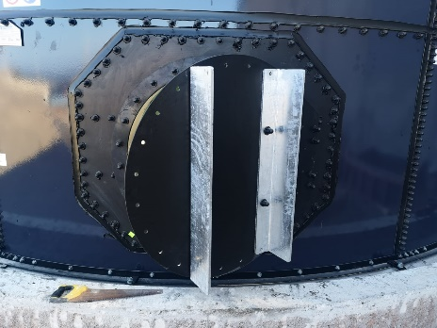

SUPPLY

T1 – Chlorination Tank
Design Code: | EN ISO 28765:2016
Certification: | None
Seismic: | Location: Egypt  Ss = 56.0 S1 = 28.0  Use Group: II  Site Class: D
Wind Speed: | 30.6m/s to be confirmed by ARTEIN prior to order placement
Specific Gravity: | 1.050
Glass Grade: | TRIFUSION®
External Colour: | Blue 20-C-40
Quantity: | 1
Model Reference: | 2805
Diameter: | 8.539m
Height: | 1.473m (less 125mm in the base)
Capacity: | 71.47m³
Freeboard: | 100mm (Sloshing Wave is greater than Freeboard - see below)
Base: | Rebate
Roof: | None
Live Load: | 0kN/m²
Snow Load: | 0kN/m²
Build Times: | We estimate that a properly equipped erection team consisting of one English speaking and suitably skilled team leader and a minimum of three semi-skilled operatives (working under the tuition of our Service Engineer) will take approximately 8 days to complete the construction of this tank kit.
Tank Ancillaries: | 1 x Ø 800mm Stainless Steel (316) tank wall access manway.  1 x Ø 150mm Stainless Steel (316) single flanged connection (BS EN 1092:2001 PN10).

T2 - Effluent Storage Tank
Design Code: | EN ISO 28765:2016
Certification: | None
Seismic: | Location: Egypt  Ss = 56.0 S1 = 28.0  Use Group: II  Site Class: D
Wind Speed: | 30.6m/s to be confirmed by ARTEIN prior to order placement
Specific Gravity: | 1.050
Glass Grade: | TRIFUSION®
External Colour: | Blue 20-C-40
Quantity: | 1
Model Reference: | 5320
Diameter: | 16.224m
Height: | 5.673m (less 125mm in the base)
Capacity: | 1043.58m³
Freeboard: | 500mm (Sloshing Wave is greater than Freeboard - see below)
Base: | Rebate
Roof: | None
Live Load: | 0kN/m²
Snow Load: | 0kN/m²
Build Times: | We estimate that a properly equipped erection team consisting of one English speaking and suitably skilled team leader and a minimum of three semi-skilled operatives (working under the tuition of our Service Engineer) will take approximately 15 days to complete the construction of this tank kit.
Tank Ancillaries: | 1 x Ø 800mm Stainless Steel (316) tank wall access manway.  1 x Ø 150mm Stainless Steel (316) single flanged connection (BS EN 1092:2001 PN10).

T2 - Effluent Storage Tank
Design Code: | EN ISO 28765:2016
Certification: | None
Seismic: | Location: Egypt  Ss = 56.0 S1 = 28.0  Use Group: II Site Class: D
Wind Speed: | 30.6m/s to be confirmed by ARTEIN prior to order placement
Specific Gravity: | 1.050
Glass Grade: | TRIFUSION®
External Colour: | Blue 20-C-40
Quantity: | 2
Model Reference: | 7620
Diameter: | 23.055m
Height: | 5.673m (less 125mm in the base)
Capacity: | 1940.38m³
Freeboard: | 900mm
Base: | Rebate
Roof: | None
Live Load: | 0kN/m²
Snow Load: | 0kN/m²
Build Times: | We estimate that a properly equipped erection team consisting of one English speaking and suitably skilled team leader and a minimum of three semi-skilled operatives (working under the tuition of our Service Engineer) will take approximately 15 days to complete the construction of this tank kit.
Tank Ancillaries: | 1 x Ø 800mm Stainless Steel (316) tank wall access manway.  1 x Ø 150mm Stainless Steel (316) single flanged connection (BS EN 1092:2001 PN10).

COMMERCIALES TERMS

Exclusions
- Access to the work must be ensured and easily accessible.
- The area around the foundations should be easily accessible from either side and leveled with the bottom plate at a minimum distance of 2m from the tank.
- The floor must be hard enough to be able to use a mobile platform.
- Foundations must meet our foundation requirements. If officially required, approval of a reinforcement must be made by an impartial design office.
- The foundations must be cured for a minimum of 28 days and have a crack resistance of a minimum of 1.5 N/mm^{2.} The foundation must withstand the loads of our tank.
- The position of 0 º must be marked and fixed for tank adjustment.
- Training/information on all aspects relevant to the customer's facilities must be ensured, as well as training in the peculiar aspects of occupational risk prevention and regulations specific to the client.
- If wind occurs (more than 4 force), durable rain, snow, frost, etc. the assembly must be stopped, which would have a deferred impact on the end date.
- Means of unloading and lifting for assembly (cranes, forklifts, etc..).
- Any masonry, civil works or land movement that results from the installation.
- Fluid rushes to consumption points.
- Electricity to work. Electromotive force required for assembly.
- Fire protection of equipment.
- Start-up products.
- Water filling and leak test to be performed and approved by the customer.
- Potential compensation, grounding and storm protection to be performed by the customer.
- Discharge media and lifting machinery needed.
- Taxes and legalizations.
- Design approval rates.
- Work plans and plans must be signed by the client before construction work began.
- The customer must provide our staff with a suitable premises or department for the storage of parts, equipment and tools, at their expense the insurance of theft or risk of loss of any element deposited in the aforementioned premises.
- It is allowed to work 10 hours a day, including the weekend.
- In general, any supply not expressly specified in this offer.

Payment method
- 50% with the order.
- 50% delivering the material.

Validity of the Offer
This offer is valid for three months.

Delivery Time
90 days from confirmation of design drawings.

Dominion Reserve
The buyer acknowledges to the seller ownership of the materials and works described in this offer until payment of the amount indicated therein, according to the payment terms established.

Warranty
- The warranty of the tanks for manufacture and assembly will be for a period of 12 months against any manufacturing or assembly defect, including this warranty defective parts. Additional periods to be negotiated at the time of the purchase order, having been defined previously.

- The warranty, except in case of hidden defect, covers the replacement in our workshop of defective parts. In case this substitution must be made outside our workshop, the warranty covers only the supply of the spare part being on behalf of the customer the amount of labor for the assembly of the same on our equipment.

- ARTEIN, is not responsible for the consequences of modifications or works carried out by the client or third person, without your prior written authorization.

- The supplier, as a result of the warranty established and comprising exclusively of the above paragraphs, accepts no other liability or claim for damages or breaches, caused directly or indirectly to the buyer.

- "Any provision of the aforementioned may be varied in its context, provided that by mutual agreement both parties, buyer and seller, so stipulate, signing the corresponding explanatory notes for this purpose".

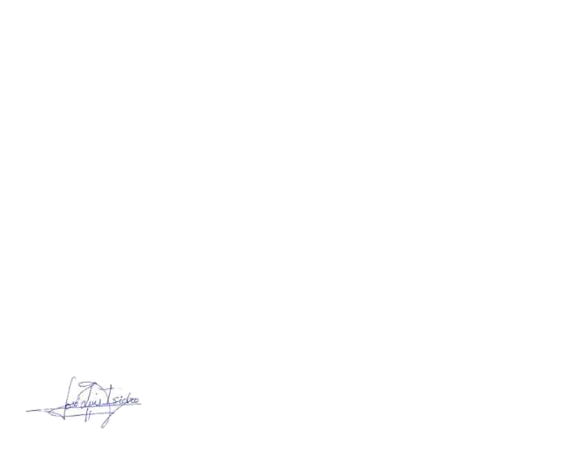
Signed. <nombre-trabajador> <apellido-trabajador>
<cargo>

